 | Application Form MS-Word Template

Executive summary of the proposal

Title*: Development of Ambient Stable, Exploratory and Cost-Effective Perovskite Quantum dots for Next Generation Flexible Photonic Applications.

Domain of research*

Summary of the project* (max 1000 words) (State the problem, strategy opted to solve the problem, including the potential translational and societal (Indian) impact. Mention the novelty and interdisciplinarity (if any):

Halide perovskites (HPs) have recently emerged as significant candidate materials for optoelectronic application. Properties such as tuneable energy bandgaps, attractive absorption, narrow emission, extraordinary charge-transport, high photoluminescence quantum yield (PLQY) and solution processability conferring perovskites a tremendous potential in the field of optoelectronic devices. The eﬃciency of perovskite solar cells has risen dramatically from 3.8% to over 22% which is comparable to polycrystalline silicon solar cell in the past several years owing to concentrated eﬀorts on the optimization of perovskite layers and device structures, interfacial engineering, and so on. All-inorganic perovskite nanocrystals (NCs) have emerged as a new generation of low-cost semiconducting luminescent systems. In the interim, their excellent inherent optical properties open up the potential application in the field of photonics and optoelectronics. Peculiar characteristics of these HPs NCs made them promising material for high-performing flexible electronics. The rapid development of flexible electronics has been driven much by the development of innovative materials. HPs NCs are suitable in photovoltaic due to a combination of their high-quality optoelectronic properties which are size dependent, inexpensive fabrication costs and ease of processing. Although the HPs NCs possess great potential, there are several challenges such as long-term stability, thermal stability, moisture stability, photostability, current-voltage (J-V) hysteresis during voltage scanning and concern associated with potential environmental impact due to the lead (Pb) contain need to addressed. In practical HPs QDs suffer from various instability issues as chemical and phase instabilities. By proper control over the HPs crystal quality and dimension the good chemical and phase stability can be achieved. However, utilization of wide spectrum towards the threshold limit is still a great challenge and needs an insightful understanding of the charge carrier generation and their separation/recombination for efficient charge carrier collection at the device.
HPs quantum dots (QDs) possess the potential of harvesting the wide range of solar power. They possess the potential for sundry optoelectronic application due to their quantum confinement effects. Though the multiple charge generation with wide range utilization of solar power for efficient conversion to electricity, the novel absorber material needs to addressed. Halide perovskites (HPs) quantum dots (QDs) are interesting due to the observed large exciton binding energy, well self-passivated surface, as well as the enhanced nonlinear properties. They also possess high photoluminescence quantum yields, size tuneable optical bandgaps and ultra-narrow band emissions, the combination of these superior optical properties and low cost fabrication makes them to be suitable candidates for display technology. Quantum confinement occurs when the semiconductor size is in the order of exciton Bohr radius. Based on the size of the QD energy bandgaps can be tuned so, it is the powerful tool to tailor the physical properties of semiconductors toward new generation functional devices. Compared with bulk materials, the quantum yields (QYs) of halide perovskite QDs reach up to 90%, making them particularly attractive for display application. The development of perovskite LEDs based on these QDs mitigates issues commonly found in LEDs based on perovskite films such as low flexibility due to thick active layers and large grain sizes, a limited device architecture due to very polar aprotic solvents used for deposition of the active layer, and a cumbersome fabrication process. As an alternative route to the fabrication of efficient perovskite LEDs(fig. 1), halide perovskite quantum dots (QDs) can be utilized in place of perovskite films. Perovskite QDs can be processed into thin solid films in nonpolar solvents and have shown enhanced PL properties, a broadened scope of device architecture, and promising device performance.
Moreover, conventional inorganic QDs have been demonstrated to retain functionality upon mechanical deformation in flexible devices. In this regard, colloidal perovskite QDs are well suited for the fabrication of efficient future of flexible electronics.
The present proposal aim is to develop absorber material with the possible new combination of HPs quantum dots. As a quantum dot possesses the potential for various optoelectronic applications due to their quantum confinement effects. Aforementioned the highest EQE reported so far is 0.19%, which is partly since the QDs are capped with relatively insulating long ligands that are required for the processing and stability of the QDs, The defects, probably vacancies and/or distorted octahedra, could act as trapping centers of photogenerated carriers, thus giving rise to poor PLQY for the band-edge emission, low light extraction efﬁciency which is caused by a large refractive index contrast between the active layer and charge injection layers.
With the possible strategy by replacing these long ligands (usually oleylamine (OAm) and oleic acid (OA)) with shorter ligands without degrading or destabilizing the QD films still the bottleneck challenge obviating its use. By replacing the long ligands with QDs capped with a halide ion pair (e.g., di-dodecyl dimethyl ammonium bromide (DDAB), di-dodecyl dimethyl ammonium chloride (DDAC)), and trioctylphosphine oxide (TOPO), octanoic acid, octylphosphonic acid (OPA), etc. a relatively short ligand that enables feasible carrier transport in the QD film and ultimately efficient devices can be built. The halide-exchang strategy can be employed to tune the emission of QDs by exploiting possible mixed halide ion pairs to obtain different colours of QDSs
The defects, probably vacancies and/or distorted octahedra, could act as trapping centers of photogenerated carriers, thus giving rise to poor PLQYs for the band-edge emission. These defects form localized defects states (deep within the band gap) which trap charge carriers and leads to the formation of indirect band gaps, which inhibits the various optoelectronic processes.
Hence the defect tolerant nanocrystals synthesis is paramount for high-efficiency perovskite QDs light emitting diodes, there is the need of judiciously selected foreign ion into the PeQD’s matrix that could increase the defect formation energy, thus reduce the defect/trap states.
Then fabrication of doped perovskite quantum dot light emitting diodes (PeLEDs) with nanophotonic substrate or embedded nanostructure for outcoupling the waveguided light to decrease the interface reflections there by increase EQE. So carrier and optical confinement can improve the PLQY and EQE to obtain high efficient devices.
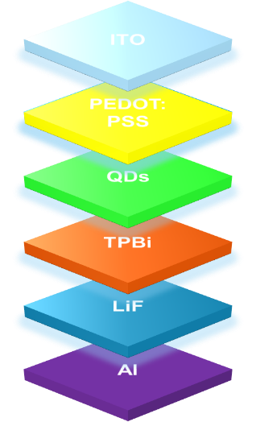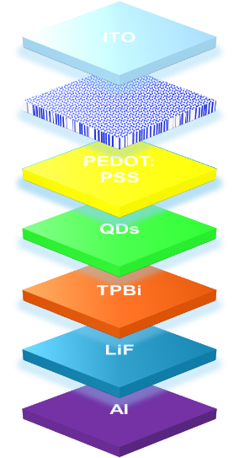
Figure 1. The schematic architecture of a QDLED device. Figure 2. The schematic architecture of a QDLED device with nanostructures.

Summary of the project file (pdf only) : <<Keep your file ready >>

Problem statement (The goal of the STARS program is to take stock of an existing problem and work backwards towards conducting scientific research for a solution. Mention how the proposed project satisfies this criteria in less than 300 words.):

The development of perovskite LEDs based on these QDs mitigates issues commonly found in LEDs based on perovskite films such as low flexibility due to thick active layers and large grain sizes, a limited device architecture due to very polar aprotic solvents used for deposition of the active layer, and a cumbersome fabrication process. As an alternative route to the fabrication of efficient perovskite LEDs, halide perovskite quantum dots (QDs) can be utilized in place of perovskite films. Perovskite QDs can be processed into thin solid films in nonpolar solvents and have shown enhanced PL properties, a broadened scope of device architecture, and promising device performance. Moreover, conventional inorganic QDs have been demonstrated to retain functionality upon mechanical deformation in flexible devices. In this regard, colloidal perovskite QDs are well suited for the fabrication of efficient future of flexible electronics and high-eﬃciency light-emitting diodes and low-threshold ampliﬁed spontaneous emissions have been accomplished by using such perovskite QDs as emissive layers.

Keywords* (maximum five):
Quantum dots, optical confinement, carrier confinement, defect states.

Objectives* (Short version: bullet points, maximum 150 words):

- The compositional engineering of HPs can be achieved by exchanging the organic [formamidinium (FA), methyl ammonium (MA)], metal (Sn, Bi,Cs,Ag,Ni), or halide (Br or Cl or I) ions.
- The compositional tuning can be achieved through partial replacement MA by FA in the alloyed MA_{x}FA_{1-x}PbI₃MA_{x}FA_{1-x}PbI₃ can extend the absorption to longer wavelengths and additionally enhance the thermal stability.
- The mixed hailde (I and Br) strategy is quite effective as the band gap of the OHPs can be controllably tuned to cover almost the entire visible spectrum from 1.5 to 2.3 eV. Additionally the bromine (Br) have the advantage of improving the water resistance of perovskites.
- The contact engineering can be performed by selective interface model and as per the device architecture.
- By incorporating the FA⁺ and Br⁻ ions into HPs as (FA_{1-y}MA_{y})Pb(I_{3-x}Br_{x}) the thermal and moisture sensitivity will improved.
- By reducing the density of mobile ions or charge traps inside the absorber and at the interfaces may alleviate the hysteresis.
- The flexibility of thin films of HPs QDs can be investigated by spin-coating the QD dispersion in toluene onto flexible PET substrates.
- Repeated bending and unbending to a different bending radii can be performed.
- Device performance and mechanical durability can be performed.
- In addition to the flexibility afforded to the LEDs by the flexible substrate and the emissive layer, high electronic performance must also be realized through careful engineering to ensure the cohesive functionality of all other layers. This cohesive functionality ensures balanced and efficient charge carrier transport and injection, determinative factors of high device performance.
- The HPs QDs were determined through cyclic voltammetry measurements to have a deep highest occupied molecular orbital (HOMO) and lowest unoccupied molecular orbital (LUMO). The deep lying HOMO level easily lends itself to charge imbalance in the OHPs QD layer, as excess electron injection may occur due to the presence of a large hole injection barrier between the QD layer and common HTL materials.
- The molecularly doped polymer hole transport layer can reduces the hole injection barrier and improves the hole transport mobility for balanced charge carriers in the device.
- To optimize the concentration, hole-only devices and electron-only devices were fabricated with the sandwich structure.
- J-V curve of these devices can be performed to see the device performance.

Technical Details
Statement of the problem* (maximum 100 words):

Numerous approaches have been proposed to improve the performance of PeLEDs. Despite the considerable improvements have been accomplished, the overall EQE still low because of

The low light extraction efﬁciency which is caused by a large refractive index contrast between the active layer and charge injection layers.

The defects, probably vacancies and/or distorted octahedra, could act as trapping centers of photogenerated carriers, thus giving rise to poor PLQY for the band-edge emission.

Imbalanced injection of electrons and holes
Long ligands do not enables feasible carrier transport in the QD film and ultimately affect the efficiency of device.

Current national and international status with appropriate references (500 words, excluding references). *:

Extensive research is currently going on in the perovskite QDs is because of their unique optical properties, high photoluminescence quantum yields, narrow tuneable band gaps by quantum confinement effect and facile synthesis. The major practical hurdles facing by perovskite QDs are related to their highly labile structures. Phase-stable, all-inorganic quantum dot based solar cells have been fabricated and demonstrated their potential utility in optoelectronic devices. This is of great importance to the field of perovskite QDs research where the current best model uses an organic-inorganic hybrid material that is thermally unstable. Nowadays scientists are working on different challenges such as, synthesising quantum dot–induced phase stabilization of α-CsPbI₃ perovskite for high-efficiency photovoltaics⁷, emissions at Perovskite Quantum Dot/Film Interface with halide anion exchange to tune the energy bandgaps⁸, on blue perovskite quantum dot light emitting diodes⁹. These days, solution-processed perovskite QDs light-emitting diodes has got tremendous focus because of the simple synthesis methodologies. Moreover, through solvent engineering strategies different types of perovskite quantum dots can be produced which have high colour purity, stability and high photoluminescence quantum yield¹⁰. When compared to organic dyes, QDs have highest absorption coefficient and more exciton radius which makes them promising complimentary to silicon solar cells that are well commercialised. A lot of research is going on in fabrication of highly flexible solar cells and light emitting diodes based on a quantum dots-polymer composite emitting layer due to its simplicity in fabrication. Large number of QDs have been explored to serve as light absorbers for mesoscopic solar cells, such as CdS, PbS, PbSe etc. Developed research on Silicon, CdTe, GaAs and other conventional semiconductors, made that photovoltaic grade electronic quality requires ultralow concentrations of impurity and crystalline defects, that all act as electronic traps or dopants. Perovskite nanocrystals are bright emitters without electronic surface passivation. People around the world are now working on material surfaces, interstitial and antisites defects, which would form deep trap states in the electronic structure, are almost absent. Metal and impurity doping which are kinetically controlled processes have emerged to substantially eliminate the intrinsic defects int the nanocrystals which influence the stability of the perovskite, increases the short-range order of the lattice and also increases the defect formation energy to avoid deep trap states in the band gap, so that photoluminescence quantum yield can be increased, which opened the door for a range of applications in perovskite based devices such as light emitting diode, single photon sources, lasers and photodetectors ¹¹⁻¹⁴. Recently colour stable and efficient white quantum‐dot light‐emitting diodes with external quantum efficiency over 23% was fabricated using a red/green/blue three‐unit tandem or a blue/green:red two‐unit tandem structure, which is a breakthrough in white quantum-dot light-emitting diodes¹⁵ . Still there is a lot to explore in this field of perovskite QD to make highly efficient devices out of it such as solar cells, LEDs, photodetectors and phototransistors.

Objectives (detailed version) of this proposal (Maximum 500 words):
- The compositional engineering of HPs can be achieved by exchanging the organic [formamidinium (FA), methyl ammonium (MA)], metal (Sn, Bi), or halide (Br or Cl or I) ions.
- The compositional tuning can be achieved through partial replacement MA by FA in the alloyed MA_{x}FA_{1-x}PbI₃MA_{x}FA_{1-x}PbI₃ can extend the absorption to longer wavelengths and additionally enhance the thermal stability.
- The mixed hailde (I and Br) strategy is quite effective as the band gap of the OHPs can be controllably tuned to cover almost the entire visible spectrum from 1.5 to 2.3 eV. Additionally the bromine (Br) have the advantage of improving the water resistance of perovskites.
- The contact engineering can be performed by selective interface model and as per the device architecture.
- By incorporating the FA⁺ and Br⁻ ions into HPs as (FA_{1-y}MA_{y})Pb(I_{3-x}Br_{x}) the thermal and moisture sensitivity will improved.
- By reducing the density of mobile ions or charge traps inside the absorber and at the interfaces may alleviate the hysteresis.
- The flexibility of thin films of HPs QDs can be investigated by spin-coating the QD dispersion in toluene onto flexible PET substrates.
- Repeated bending and unbending to a different bending radii can be performed.
- Device performance and mechanical durability can be performed.
- In addition to the flexibility afforded to the LEDs by the flexible substrate and the emissive layer, high electronic performance must also be realized through careful engineering to ensure the cohesive functionality of all other layers. This cohesive functionality ensures balanced and efficient charge carrier transport and injection, determinative factors of high device performance.
- The HPs QDs were determined through cyclic voltammetry measurements to have a deep highest occupied molecular orbital (HOMO) and lowest unoccupied molecular orbital (LUMO). The deep lying HOMO level easily lends itself to charge imbalance in the OHPs QD layer, as excess electron injection may occur due to the presence of a large hole injection barrier between the QD layer and common HTL materials.
- The molecularly doped polymer hole transport layer can reduces the hole injection barrier and improves the hole transport mobility for balanced charge carriers in the device.
- To optimize the concentration, hole-only devices and electron-only devices were fabricated with the sandwich structure.
- J-V curve of these devices can be performed to see the device performance.

Detailed work plan to achieve the objectives (Maximum file size 5 MB, PDF Only) : <<Keep your file ready >>
Design, synthesis of stable Halide Perovskites (HPs) Quantum dots (QDs) and regulate the bandgap

- From our previous results the ligand exchange strategy can be employed to develop HPs quantum dots (QDs) and can be synthesize in organic solvents which are typically protected by long-chain aliphatic molecules like oleic acid (OA) and oleylamine (OAm). These hydrocarbon chains are electronically insulating, and act as potential barriers in QD-based optoelectronic devices. To resolve this, short-chain ligand exchange methods are used for developing conventional QDs solar cells, toward reducing the resistance of the photo-active layer. The effect of the ligand type and length on the optical properties of PeQDs can be investigated.
- QDs capped with a halide ion pair (e.g., di-dodecyl dimethyl ammonium bromide (DDAB), di-dodecyl dimethyl ammonium chloride (DDAC)), and trioctylphosphine oxide (TOPO), octanoic acid, octylphosphonic acid (OPA), etc. a relatively short ligand that enables feasible carrier transport in the QD film and ultimately efficient utilization for PeLEDs application.
- PeQDs passivated with short rigid ligands might be more optically stable due to the dense overcoating of the QDs, and could also advantageously influence the PeQLED performance by decreasing the potential barrier of the PeQD film after the ligand exchange process, compared to that of the as-synthesized PeQDs with long hydrocarbon tails. Ligand exchange experiments were carried out using ligands with different chain lengths, and it turned out that the solubility of the treated PeQDs in hydrophobic solvents could be dramatically modified depending on the ligand length. This was adjusted by tuning the ratio of the employed ligands and the polarity of solvents, which is essential to fabricate a nanocrystal film with high surface coverage, resulting in the superior performance of the PeQLEDs.
- In the ligand exchange experiment with short chain ligands including aromatic acid/amine, the solubility of the treated PeQDs in hydrophobic solvents gradually decreased with an increase in the ratio of the short-chain ligands on the surface of the QDs. This indicated that the PeQDs with short-chain ligands became less sterically hindered than those with the original long-chain ligands, resulting in the precipitation of PeQDs when all the long alkyl chain ligands were exchanged with the short chain ones.
- Octane was adopted as a key solvent, because aromatic acid/amine has a low solubility in octane, whereas the solubility of long alkyl chain ligands in it is quite high. This implies that it is difficult for short chain ligands to diffuse out into the solvent during the ligand exchange process and that the surface defects formed by the ligand dissociation can be minimized, thereby conserving the high photoemission property. In addition, benzene is essential to dissolve the aromatic short chain ligands such as Benzoic acid, or 4-Phenylbutylamine in our experiments in spite of its relative toxicity.
- Branched capping ligands such as trioctylphosphine oxide (TOPO) are usually regarded as good capping ligands for improving the stability of NCs because they can provide strong steric effect. Because of the highly branched molecular structure and relatively strong coordination ability of P=O group, TOPO is featured by high stability against high temperature treatment and effective protecting effect originated from the strong steric effect.
The overall methodology will be sequenced as below.
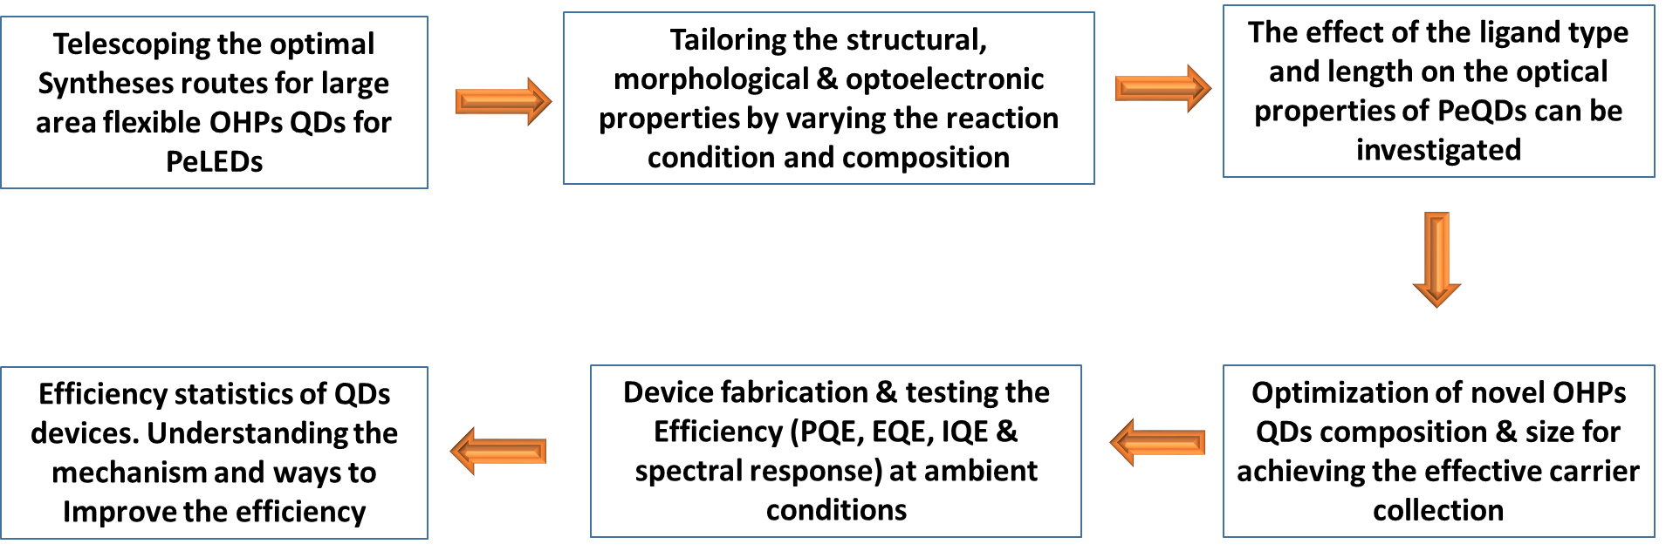

- Preliminary activities by the Indian side
- A two-step ligand-exchange strategy is developed, in which the long-carbon-chain ligands on HPs quantum dots (QDs) (e.g., di-dodecyl dimethyl ammonium bromide (DDAB), di-dodecyl dimethyl ammonium chloride (DDAC)) are replaced with halide-ion-pair ligands. As a relatively short chain ligand can feasible the effective carrier transport in the QD film which is beneficial in PeLEDs application. The other short chain (octanoic acid, octylphosphonic acid (OPA)) and branched chain ligand (trioctylphosphine oxide (TOPO)), are also explored for the effective carrier transport in the QDs film. The ligand-exchange strategy can be used to tune the emission of QDs by exploiting possible mixed halide ion pairs. The doping at lead cation site can also be explored.
- Halide ligand passivation: To reduce defect density while keep high carrier mobility, halide ligands have been explored for CQD passivation. The atomic sizes of halide ligands allow efficient carrier transport between CQDs; while the strong binding of halides to CQD surfaces offers the capacity to improve surface passivation.
- Hybrid Ligands: Hybrid materials that combine organic crosslinkers and inorganic passivants.
- Compared with organic ligands, metal chalcogenide complexes ligands effectively improve film conductivity, while halide ligands reduce defect density. However, ligand loss in exchange process is still one major issue that limits device performance. To avoid ligand loss the two step ligand exchange strategy can be adapted.
- Compared with solid-state ligand exchange, the lack of steric hindrance in the solution phase treatment increased accessibility and binding. Although the solution-phase halide ligand treatment partly replaces organic ligands, the exchange was not complete and the solid-state ligand exchange process was still needed to remove organic ligands completely.

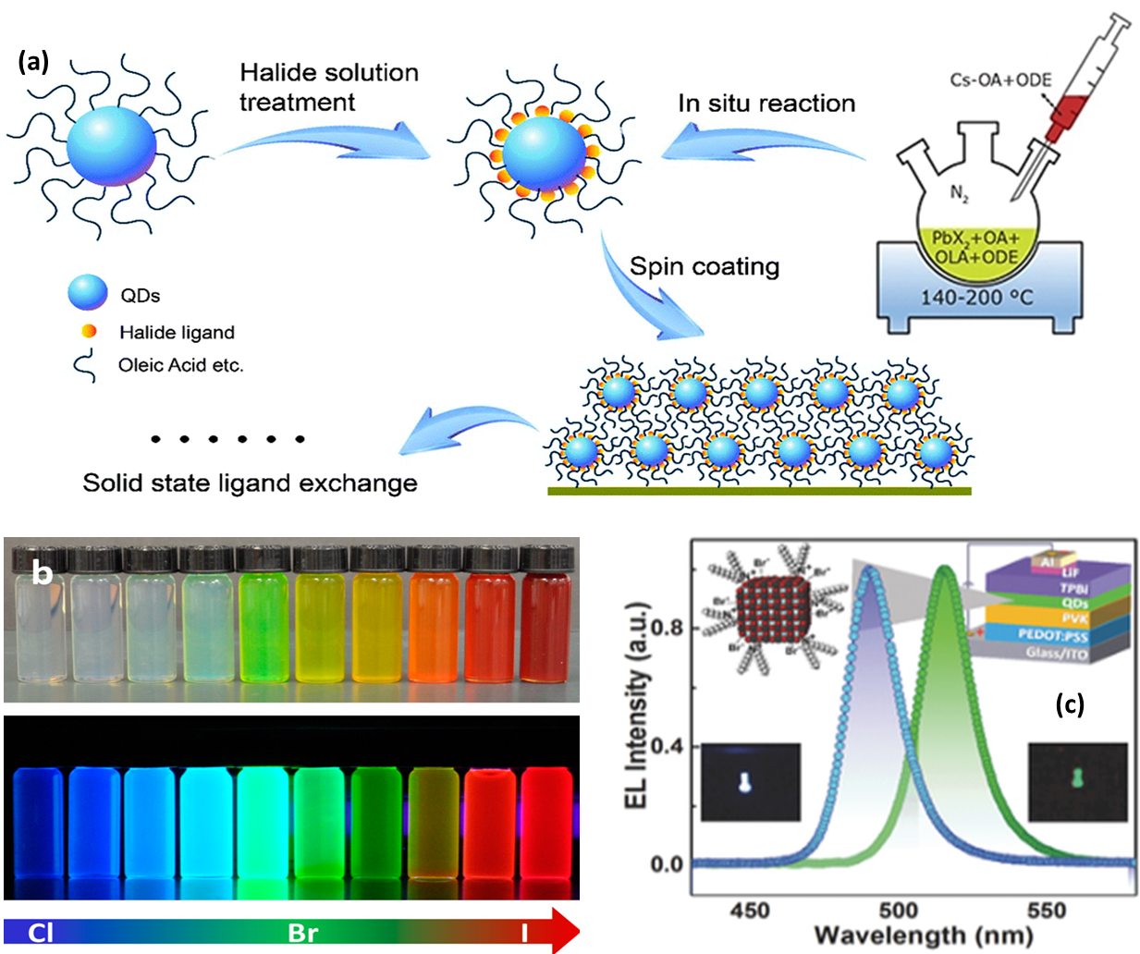

QDs ligand exchange and solution preparation:
- The patterned ITO-glass substrates were cleaned with deionized water, acetone, and isopropanol in sequence, followed by oven-drying and O₂ plasma treatment (FEMTO) for required time.
- The ligand-exchange strategy can be employed to tune the emission of QDs by exploiting possible mixed halide ion pairs.
- For high-efficiency perovskite light emitting diodes, there is the need of judiciously selected foreign ion into the PeQD’s matrix that could increase the defect formation energy, thus reduce the defect/trap states.
- Then fabrication of doped perovskite quantum dot light emitting diodes (PeLEDs) with nanophotonic substrate or embedded nanostructure for outcoupling the waveguided light.

- PEDOT:PSS was deposited onto the substrate by spin-casting and annealed for required duration in air.
- Colloidal OHPS ODs solution was spin-coated onto PEDOT:PSS to form the QDs layer. The remaining functional layers and aluminum electrodes were fabricated by thermal evaporation in a single run at a base pressure without breaking the vacuum.
- All the organics were evaporated at a specified rate and the aluminum electrodes were evaporated.
- A shadow mask was used to define the cathode. All devices were completed with rudimentary encapsulation in glovebox for characterization in air at room temperature.
- The PEDOT:PSS film here serves as the ITO modification layer to enhance the injection and transport of hole. The pure TPBi and B3PYMPM films serve as electron transport layer (ETL). The TPBi:Cs₂CO₃ and B3PYMPM:Cs₂CO₃ films serve as the n-type doped electron injection layer (EIL), which can enhance the electron injection and decrease the driving voltage effectively.
- PVK is used as a hole-transporting and electron-blocking layer while TPBi is employed as an electron-transporting layer. The PVK layer reduces the hole-injection barrier, blocks the electrons in the active layer, and hence allow the holes and electrons to recombine effectively in the QD emitting layer.
- All blended function layers were deposited using multisource coevaporation.
- Electron-Only, hole only Devices Control Devices Champion Devices were fabricated and studied for PeLED application.

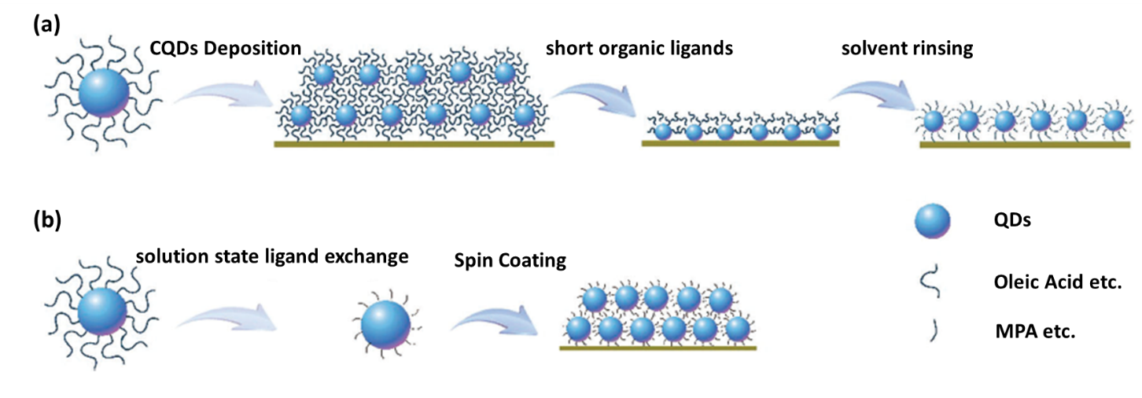

(Provide detailed description of the proposed research, highlighting the novelty of your approach. Please include figures, schematics, references, tables etc. Also include a time schedule of activities (with milestones) through BAR diagram.)

Scientific significance of the proposed work (Max 200 words):

With the possible strategy by replacing these long ligands on QDs (usually oleylamine (OAm) and oleic acid (OA)) with shorter ligands enables feasible carrier transport in the QD film and ultimately efficiency of the device can be improved without degrading or destabilizing the QD films.
The halide-exchange strategy can be employed to tune the emission of QDs by exploiting possible mixed halide ion to obtain different colours of QDs.
The defects, probably vacancies and/or distorted octahedra, could act as trapping centers of photogenerated carriers, thus giving rise to poor PLQYs for the band-edge emission. These defects form localized defects states (deep within the band gap) which trap charge carriers and leads to the formation of indirect band gaps so that non-radiative recombination will take place in the semiconductors, which inhibits the various optoelectronic processes. Hence the defect tolerant nanocrystals/QDs can be synthesised be doping appropriate element so the carrier confinement can be improved.
Followed by incorporating nanostructures in fabrication will decrease the interface reflections so that the optical confinement will be improved. By the dual confinement (carrier and optical) and replacement of long ligands by short ligands, high brightness and high EQE can be obtained.

Translational potential of the proposed work (Max 200 words):
By designing the suitable HPs QDs, we are looking forward to obtain the following properties.
- Facile low temperature solution-based fabrication technique.
- HPs QDs with flexible large area next generation electronics.
- HPs QDs with high absorption coefficient and long-term stability in air ambient.
- Research outcome of the proposed project can be used in the following industries
- Solar cell industry: The current research unveils the potential for using the novel HPs QDs layers for highly efficient flexible next generation electronics. Upon successful incorporation of these HPs QDs in the small prototype cells, these prototypes would be used for module level production in the flexible electronics, leading to the establishment of the new such industries.
- Chemical companies: These novel HPs QDs which are robust, air stable and highly pure in nature will be useful for the semiconductor industries for various photonic applications that span from the lasing applications, photodiodes, photodetectors, sensing applications, X-ray detectors, etc.

Relevance of the proposed work to India (Max 200 words):

Prior expertise of the investigators related to the area (Max 200 words):
The Indian PI will design and develop the novel stable HPs QDs and studied its structural and optoelectronic properties. The photo physics of the developed material will be intensively investigate. With ligand exchange strategy the surface engineering of the developed QDs will be addressed to the PeLED application. With the short-chain ligand exchange methods are used for developing conventional QDs solar cells, toward reducing the resistance of the photo-active layer. The effect of the ligand type and length on the optical properties of PeQDs can be investigated. In order to improve the branched chain ligand can also be exchanged. The thickness and the size of the developed QDs was optimized for maximum PLQY efficiency. The J-V-L characteristics and the EL spectra of the LEDs were collected with an adhesive encapsulation in the dark room.
Based on measured parameters of the band structure, absorption coefficient and lifetime of electron-hole pairs, generated by light, we will estimate the influence of cesium doping and the role of mixed halide ions on the PLQE of HPs QDs with the aid of computer simulations. Above mentioned parameters of the perovskite slab should be measured before a final PeLEDs structure fabrication. This procedure will allow us to analyze various types of cesium doped PeLEDs and different halide ions with minimal expenses. Electronic properties can be predicted by theoretical stimulations. They can suggest the optimal architecture of photodetectors on the basis of the theoretical analysis. Band edge positions of semiconductors determine their functionality in many optoelectronic applications such as photovoltaics, photoelectrochemical cells and light emitting diodes. Quantum dots (QDs), can be tuned through surface chemistry modification. By combining experiments and ab initio simulations, we establish clear relationships between QD surface chemistry and the band edge positions of ligand/QD hybrid systems.

List five publications (with journal impact factor and number of citations) from the PI and all CO-PI relevant to the proposed area of work. Details should include title, authors, name of the journal, issue & page number, year of publication. Also provide summary of the work reported in each publication in not more than 100 words. For patents, please provide details of commercialization/licensing (if any) in 100 words or less.):

1.Remarkably high conversion efficiency of inverted bulk heterojunction solar cells: From ultrafast laser spectroscopy and electron microscopy to device fabrication and optimization Qana Alsulami†, Banavoth Murali†, Yara Alsinan, Manas R. Parida, Shawkat M. Aly, Omar F. Mohammed, Advanced Energy Materials, Wiley, 6, 11, 2016, 1502356. DOI: 10.1002/aenm.20150235.
2.Highly Efficient Perovskite‐Quantum‐Dot Light‐Emitting Diodes by Surface Engineering.
Pan, J., Quan, L. N., Zhao, Y., Peng, W., Murali, B., Sarmah, S. P., ... & Yassitepe, E. Advanced Materials (2016)., 28(39), 8718-8725.
3.Engineering of CH3NH3PbI3 Perovskite Crystals via Alloying Large Organic Cations for Enhanced Thermal Stability and Transport Properties, Wei Peng, Xiaohe Miao, Valerio Adinolfi, Erkki Alarousu, Omar El Tall, Abdul-Hamid Emwas, Chao Zhao, Grant Walters, Jiakai Liu, Olivier Ouellette, Jun Pan, Banavoth Murali, Edward H. Sargent, Omar F. Mohammed, and Osman M. Bakr, Angewandte Chemie International Edition, Wiley, 55, 36, 2016, 10686 –10690. DOI: 10.1002/anie.201604880.
4.Robust and Air-Stable Sandwiched Organo-Lead Halide Perovskites for Photodetector Applications, Banavoth Murali, Makhsud I. Saidaminov, Ahmed L. Abdelhady, Wei Peng, Jiakai Liu, Jun Pan, Osman M. Bakr, Omar F. Mohammed, Journal of Materials Chemistry-C, RSC, 4, 2016, 2545-2552. DOI: 10.1039/C6TC00610H.
5.High-quality bulk hybrid perovskite single crystals within minutes by inverse temperature crystallization, Makhsud I. SaidaminovAhmed L. Abdelhady, Banavoth Murali, Erkki Alarousu, Victor M. Burlakov, Wei Peng, Ibrahim Dursun1, Lingfei Wang, Yao He, Giacomo Maculan, Alain Goriely, Tao Wu, Omar F. Mohammed & Osman M. Bakr, Nature Communications, Nature Publishing Group, 6, 2015, 7586. DOI:10.1038/ncomms8586.
6.Double Charged Surface Layers in Lead Halide Perovskite Crystals, Sarmah, Smritakshi ; Burlakov, Victor ; Yengel, Emre; Banavoth Murali; Alarousu, Erkki; El-Zohry, Ahmed; Yang, Chen; Alias, Mohd; Zhumekenov, Ayan; Saidaminov, Makhsud; Cho, Namchul; Wehbe, Nimer; Mitra, Somak; Ajia, Idris ; Dey, Sukumar; Mansour, Ahmed E.; Abdelsamie, Maged; Amassian, Aram; Roqan, Iman; Ooi, Boon; Goriely , Alain ; Bakr, Osman; Mohammed, Omar, Nano Letters ACS, 17, 2017, 2021-2027. DOI: 10.1021/acs.nanolett.7b00031.
7.Quantum dot–induced phase stabilization of α-CsPbI₃perovskite for high-efficiency photovoltaics.Swarnkar, A., Marshall, A.R., Sanehira, E.M., Chernomordik, B.D., Moore, D.T., Christians, J.A., Chakrabarti, T. and Luther, J.M., 2016. Science, 354(6308), pp.92-95.
8. Emissions at Perovskite Quantum Dot/Film Interface with Halide Anion Exchange to tune the energy bandgaps
Liu, Y., Li, F., Li, Q., Yang, K., Guo, T., Li, X. and Zeng, H., 2018 5(11), pp.4504-4512.
9.Blue perovskite light-emitting diodes
Kumawat, N.K., Liu, X.K., Kabra, D. and Gao, F., 2019. Nanoscale, 11(5), pp.2109-212.
10.All-Solution-Processed Perovskite Quantum Dots Light-Emitting Diodes Based on the Solvent Engineering Strategy
Yang, K., Li, F., Liu, Y., Xu, Z., Li, Q., Sun, K., Qiu, L., Zeng, Q., Chen, Z., Chen, W. and Lin, W., 2018. ACS applied materials & interfaces, 10(32), pp.27374-27380.
11.Solvent Polarity: How does this Influence the Precursor Activation, Reaction Rate, Crystal Growth and Doping in Perovskite Nanocrystals?
Dutta, A., Behera, R.K. and Pradhan, N., 2019. Solvent Polarity: How does this Influence the Precursor Activation, Reaction Rate, Crystal Growth and Doping in Perovskite Nanocrystals?. ACS Energy Letters.
12. Exciton-to-dopant energy transfer in Mn-doped cesium lead halide perovskite nanocrystals Parobek, D., Roman, B.J., Dong, Y., Jin, H., Lee, E., Sheldon, M. and Son, D.H., 2016.. Nano v letters, 16(12), pp.7376-7380.
13.Doping Semiconductor Nanocrystals.
Erwin, S.C., Zu, L., Haftel, M.I., Efros, A.L., Kennedy, T.A. and Norris, D.J., 2005. Doping semiconductor nanocrystals. Nature, 436(7047), p.91.
14.An alternative of CdSe nanocrystal emitters: pure and tunable impurity emissions in ZnSe nanocrystals.
Pradhan, N., Goorskey, D., Thessing, J. and Peng, X., 2005.. Journal of the American Chemical Society, 127(50), pp.17586-17587.
15.Lead‐free, blue emitting bismuth halide perovskite quantum dots
Leng, M., Chen, Z., Yang, Y., Li, Z., Zeng, K., Li, K., Niu, G., He, Y., Zhou, Q. and Tang, J., 2016.. Angewandte Chemie International Edition, 55(48), pp.15012-15016.

Environmental risk considerations for the proposed work (max 200 words) (Please highlight the potential risks of the proposed work, and steps taken to ensure safe laboratory practices. Endorsement from safety and ethical committee of the institute/university must be uploaded as a single pdf file (max size 3 MB) for work involving pathogens and/or animals.) :

The project we designed on stable Halide Perovskites (HPs) Quantum dots (QDs) have some unique advantages, such as the solution-processability, infinite variety, good stability, low-cost, environment-friendly, easy fabrication, tenability of electronic properties and mechanical flexibility. Apart from that the reaction conditions don’t involve any maintenance of high temperature reactions. The proposed project deals with the materials which are biocompatible, environmentally friendly. Hence, it causes no pollution, no nuclear radiation, no wastage of water or electricity and no other waste products.

Summary of roles and responsibilities for all PI & CO-PI* ((Max 200 words)):

Budget details
(Quotations will be necessary at a later stage, if the project is approved.)
Budget summary (in Lakhs) (General guideline for STARS project is to have up to 50 Lakhs for single PI projects, and up to 100 lakhs for multi-PI projects.)
* If any section of the budget exceeds the given limit, please give justification in the corresponding justification box.
Sl No | Title | Year 1 | Year 2 | Year 3 | Total
1 | Human Resources
2 | Equipment
3 | Consumables
4 | Contingency  Maximum budget for contingency should be less than 6% of the total cost (i.e. 3 lakhs for a total project cost of 50 lakhs)
5 | Facility charges
6 | Travel  Maximum budget for travel head should be less than 6% of the total cost, unless the project requires extensive field work.
7 | Overhead  (10% of total project cost or 5 lakhs, whichever is more)
 | TOTAL

- Justification and cost breakup of Human Resources to be hired (mention proposed salary and position, must conform to GOI and institute rules):
To carry out the synthesis of the perovskite absorbers and followed by the fabrication and testing the devices, a minimum of two research associates (RA) are needed. One RA will involve in the synthesis of the precursor materials, and the other would involve in the fabrication. Since these are high efficiency based solar cell fabrication, it needs an expert hand. Therefore, research associates will be preferred to handle the vacuum deposition thermal evaporation chambers for depositing the electrode materials such as Au, In, Ag etc. Moreover, the certified testing of the solar cell efficiency would also involve travel one research associate while the other continues to work on the fabrication. Therefore, I request for two RA’s in this project to come up with a high-efficiency working prototype for possible commercialization.

2. Justification and cost breakup of All Equipment:

3. Details of Consumables and Cost breakup:

All these chemicals along with patterned ITO substrates will be used for the fabrication of the single crystal solar cells. Of these chemicals contain the active layer absorber materials, hole and electron transport materials. The active layers consist of MAPbBX3, FAPbBX3 where X = Cl-/Br-/I- and MA = CH3 NH2 and FA = CH3 NH2. Most of the high-efficiency solar cells are constructed from the particular batch of chemicals, for instance, as mentioned in the table, the bromides and iodide based salts need to be procured from Dyesol, Australia. There are instances, when we have used these aforementioned chemicals from other manufacturers, there was a problem with the solubility of these chemicals thereby pin hole films, low open circuit voltages and poor performances. Therefore, for better reproducibility and stable devices, we need to procure the chemicals from the listed manufacturers.

4. Justification of Contingency budget:
The contingency would involve in buying the books on photovoltaics, attending the local, national conferences and symposiums for scientific interactions. Importantly the characterization of the devices would involve the analytical charges at other institutes where there is the availability of the facilities. The certification of efficiency from the standard authorized labs such as NREL (National Renewable Energy Laboratory, Colorado, USA) would be met from the contingency grants. Such certification is mandatory for the highly efficient devices for even applying for the patents. The miscellaneous expenses include the stationery items, software such as origin, endnote, LabVIEW, solid works, etc. Since we are dealing with the lead based toxic chemicals, there is a need for the flammable/ non-flammable safety cabinets. For storing the synthesized precursors, the refrigerator is also required. For drying/ solvent removal from the films, vacuum setup is required which involves a vacuum chunk with the rotary pump. The cleaned substrates will require to be blown from nitrogen gas and provide with UV-O3/ Oxygen-Argon plasma depending on the type of film grown. Therefore, the basic plasma- prine setup is needed for this work. The continuous need for the thermal evaporation materials such as Au, Ag, Al, In, Ca etc., will be met from the contingency grants.

5. Justification and cost breakup of Facility Charges:

6. Justification of Travel budget:

The exchange visits of both the Korean or Indian scientists would involve the air flight tickets, medical insurance, and their accommodation stay at the university. The number of visits will depend on the work progress. However, there will be a need for at least two visits per year

7. Justification of Overhead budget:

Other administrative details

1. Details of Projects under implementation
Funding agency and role (PI/CO-PI) | Title of the project | Amount granted (Rs.) | Start date | End date

2. Details of Projects completed during the last 5 years
Funding agency and role (PI/CO-PI) | Title of the project | Amount granted (Rs.) | Start date | End date

3. Suggested reviewers (minimum 5 experts working in India, 2 experts from abroad)

Name of expert | Department and University/Institute/Company | Email | Areas of expertise | Webpage / google scholar page (if available)

4. List of facilities being extended by parent institution(s) for the project implementation
Sr. No. | Infrastructural Facility | Yes/No/ Not required Full or sharing basis
1 | Workshop Facility
2 | Water & Electricity
3 | Laboratory Space/ Furniture
4 | Power Generator
5 | AC Room or AC
6 | Telecommunication including e-mail & fax
7 | Transportation
8 | Administrative/ Secretarial Support
9 | Information facilities like Internet/ Library
10 | Computational Facilities
11 | Animal/ Glass House
12 | Cryogenic Facility
13 | Bio-imaging Facility
14 | Nanofabrication Facility
15 | Nano Characterization Facility
16 | Any other facility crucial for the project

Equipment available with the Institute / Group / Department for the project.
(Apart from what will be purchased as part of this project):

List of documents to be uploaded along with the proposal

CV of all the PIs Each CV: max three pages, file size max 1 MB, PDF only: <<Keep your file ready >>

Declaration from the PIs (see Annexure I) (file size max 1 MB, PDF only) : <<Keep your file ready >>

Endorsement from head of organization (see Annexure II) (file size max 1 MB, PDF only) : <<Keep your file ready >>

Endorsements from safety /ethical committee (if applicable, upload as one pdf file in Annexure III) ((file size max 3 MB, PDF only) : <<Keep your file ready >>

Any other information that may be relevant to the project (max 2 MB) (optional), PDF only: <<Keep your file ready >>

